Use this resource to view a student record.

View student records to quickly access academic history, track academic progress, and perform other actions.

INSTRUCTIONS

- Log into Workday. In the search bar, type “Student: [Student’s first and last name]”. Click the student record once it auto-populates.

- You will immediately land in the student record.

To print the student record, click the PDF symbol and select the categories to be included.

To email the student, click “Email” and click the email address. A new window will open in your email application.
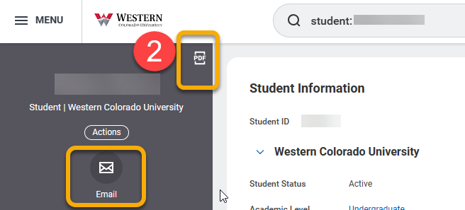

- To view the student’s academic information, click “Academics” in the left-hand menu. You will see six tabs: Overview, Current Classes, Plan, Academic History, Academic Progress, and External Records.

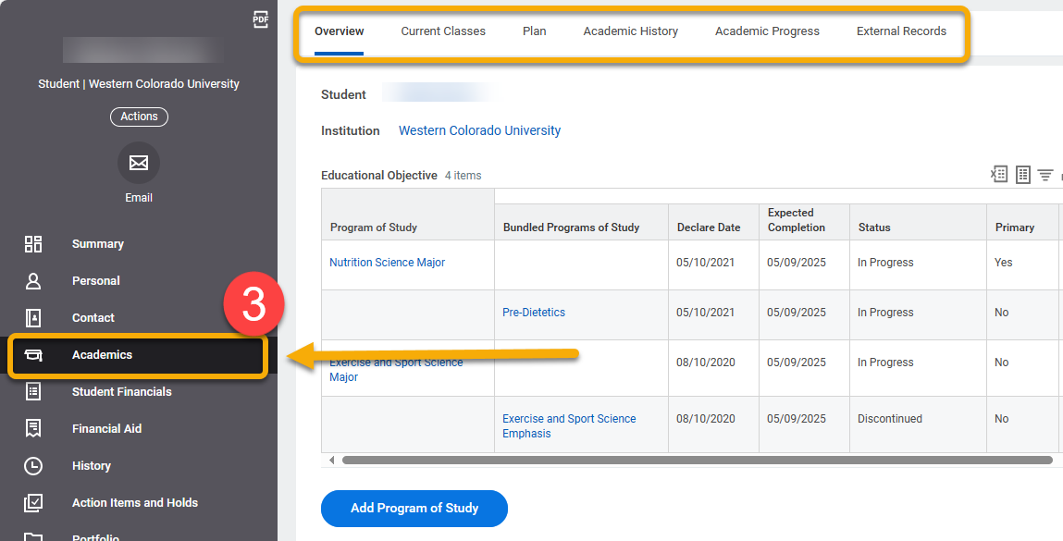

- To view general current course information, click the “Current Classes” tab to display current course schedule in list or calendar view.

To edit current course section hours or grading basis, click “Edit Registration”.
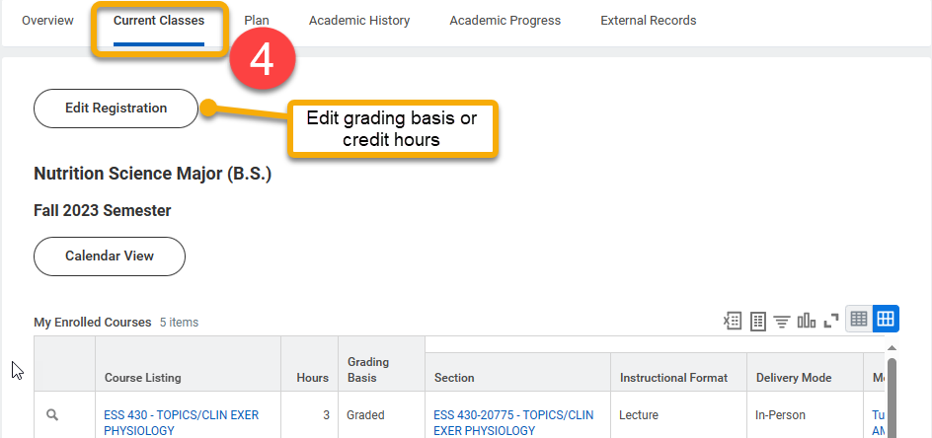

- To view past course information, including credits earned, GPA, and grades, click “Academic History”.

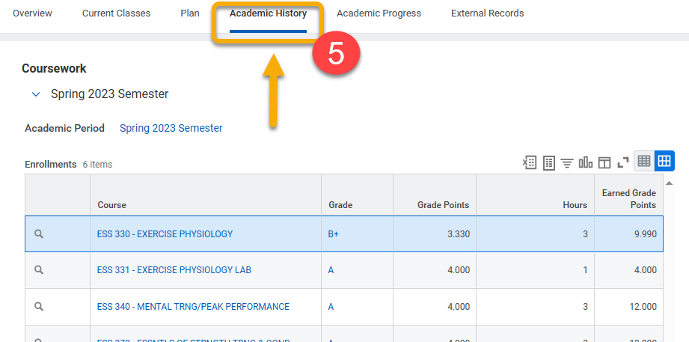
This page will outline course sections, grades, grade points, and hours for each past academic period.

Scroll down to view Academic Period Totals.
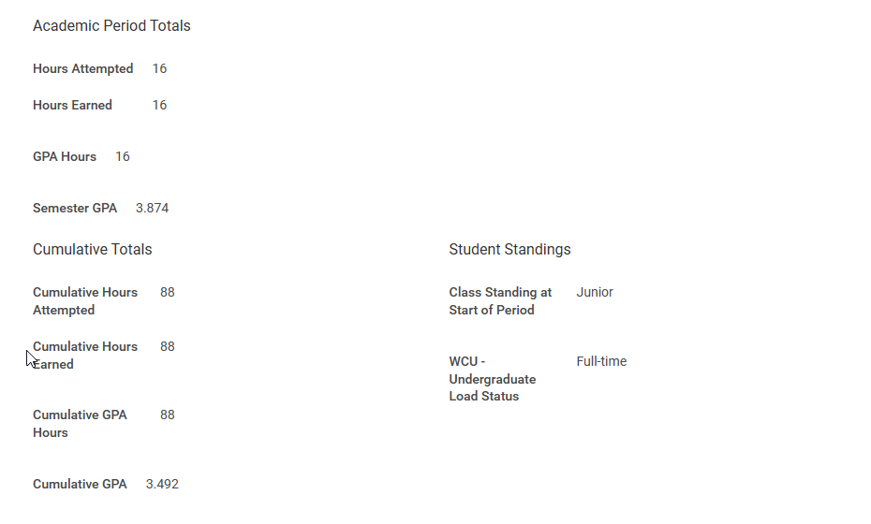

- To view student progress towards academic requirements, click “Academic Progress”.

Academic progress is not automatically updated. The student’s advisor must manually update this information. The Last Evaluated timestamp notes the most recent update.

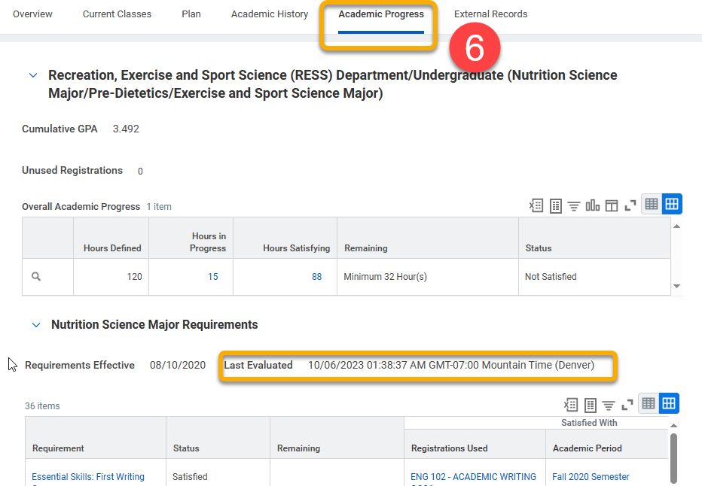

TIP: Click the carrot next to the number in “Hours in Progress” or “Hours Satisfying” to reveal an option to download and print the list of courses as excel or PDF.

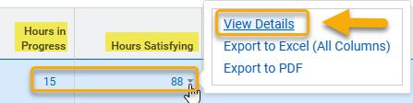

- To view all holds on the student record, click “Action Items and Holds” in the left-side menu.
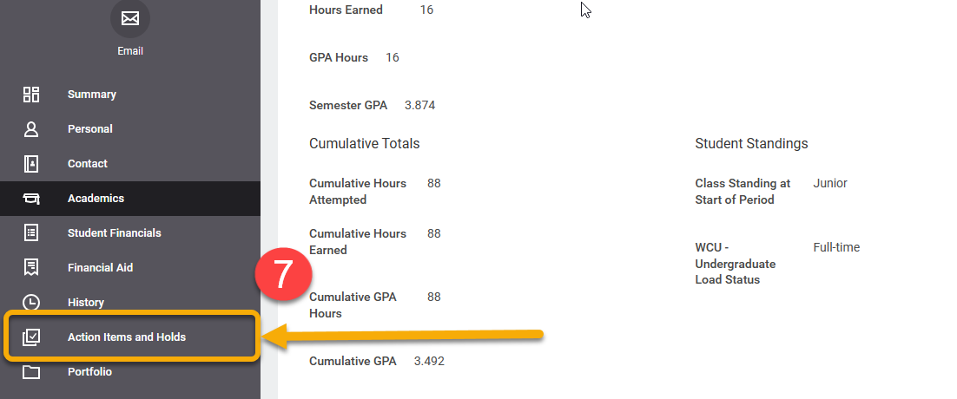
- This will reveal three tabs: Review Action Items, Active Holds, and Resolved Holds. Advisor holds are found in the Active Holds tab.

Item | Description
Action Items | View active items in Financial Aid, Admissions and Onboarding.
Active Holds | View active holds, descriptions, resolution instructions and what activities the hold prevents.
Resolved Holds | Review history of holds, reasons for holds, resolution instructions, hold types, date resolved and who the hold was removed by.

